Science Mission: Through a Cooperative Agreement with the National Science Foundation, Battelle is constructing the National Ecological Observatory Network (NEON) as a research platform designed to study the biosphere at regional and continental scales and to conduct real-time ecological studies at the scales required to address grand challenges in ecology. www.NEONScience.org
Facility Description: NEON is a new nationwide, “shared-use” research platform of field-deployed instrumented towers and sensor arrays, sentinel measurements, specimen collection protocols, remote sensing capabilities, natural history archives, and facilities for data analysis, modeling, visualization, and forecasting. NEON assets are managed with a cyberinfrastructure of networked processing routines, repositories, and interfaces. The Observatory also supports multi-sensor aircraft payloads (AOPs) operated from leased Twin Otter aircraft, and five mobile deployment platforms (MDPs) that contain both terrestrial and aquatic instrumentation. NEON construction will be completed within the next year.
Key Products & Services: The continental-scale cyberinfrastructure serves 181 data products from 20 regional eco-climatic domains which consist of terrestrial, aquatic, and aerial sampling from over 350 staff. To enable researchers to answer major ecological questions, NEON collects data on a suite of biotic and abiotic variables. As a national research platform, infrastructure, sampling methods, and measurements are being standardized and provided via extensive metadata associated with each downloadable data product. Consistency in collection across locations, through the use of standardized sensors, protocols, and processes, is required to ensure the validity and usability of NEON data by the scientific community and other stakeholders. NEON staff, in concert with automated procedures, evaluate data quality.
The NEON cyberinfrastructure includes models and related computational resources for delivering a range of value-added “data products” based on the in-situ, experimental, and remote sensing components. These models and algorithms perform quality control processing, classification, scaling and interpolation functions, as well as provide a platform for external researchers accessing the data to detect patterns, test hypotheses, and project ecological forecasts against seamless, continental scale data layers.
The cyberinfrastructure, which is headquartered in Colorado, publishes both real-time provisional data, and annual releases of observatory-wide versions of results. The cyberinfrastructure architecture is built across facilities which range from the central, commercial data center, to headquarters development environments, to cloud-based data acquisition/staging applications, to distributed sites with dedicated local unmanned facilities, communications, routing controls, and local data logging. Repository content is managed via a central object store, a portfolio of relational databases, and shared code libraries. The cyberinfrastructure includes numerous operational subsystem including: ingest; archival; calibration; processing pipelines; metadata management; specimen custody management, and publishing functions. NEON’s web presence consists of interactive portals to data assets, community services, and application programming interfaces (API).
The cyberinfrastructure development team uses best practices approaches to software development via an iterative approach to development (using industry-standard Agile methodology) that stresses the evolving nature of requirements gathering and development. The team emphasizes best practices engineering principles, including code re-use and definition of interfaces to facilitate object-oriented software integration and provide a basis for future growth. Formalized QA methods are applied to in unit, integrated, and regression testing. Segregated development, test, integration, and production environments control releases. The NEON cyberinfrastructure is designed to invite incremental improvements through incorporation and testing of open-source code from community members.
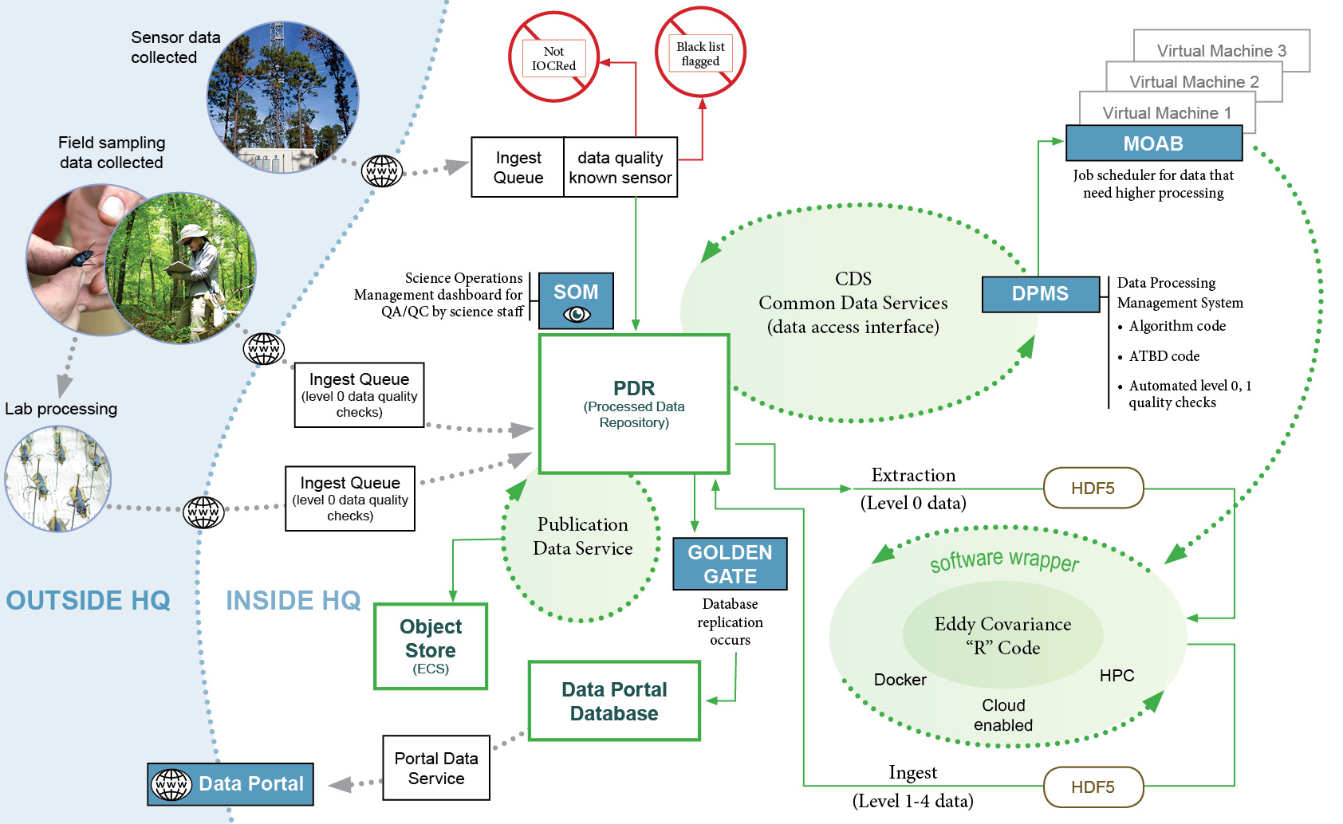
Figure 1. Generalized landscape of data flow through the NEON cyberinfrastructure.

Management & Community Engagement: Leadership is conducted from the NEON Project headquarters in Boulder, Colorado, where core science, management, and administrative functions for the Observatory is managed through the 30-year operational life. NEON’s operation is periodically adapted through guidance from the Science, Technology, and Education Advisory Committee (STEAC). Community input is facilitated by 20+ Technical Working Groups. Some NEON products are hosted by community partner organizations: BOLD; SRA; MG-RAST; PhenoCam; AeroNet; AmeriFlux, and DataOne. NEON participants include dozens of laboratories, universities, and agencies. Initial user statistics reflect over 10,000 users from domestic and international organizations.

